*This is a generic operator guide, intended to be taken and customised as a manual for operating metadata submissions to ANDS as an institutional service. This is based on an actual service manual used at Victoria University. Please change the highlighted text to your local contacts, reviewers, and settings.*

Roles involved:

* Researcher – submitter or originator of metadata
* PRIMARY CONTACT – promotes use of RDA, potentially assists researcher in creating metadata
* METADATA REVIEWER – checks quality of metadata, responsible for technical interface to RDA

Draft of service process:

1. Researcher contacts PRIMARY CONTACT for brief query about registering datasets/collections in Research Data Australia. Researcher is sent email containing link to online form.
2. Researcher fills out form. PRIMARY CONTACT to answer further questions if necessary.
   1. (an email is sent to PRIMARY CONTACT on saved form)
3. PRIMARY CONTACT **check** saved form entry is complete.
   1. Login to WordPress as admin (admin/?password?).
   2. From the WordPress homepage go to “List All” and click “EDIT” on the saved form entry. The most recent should be listed first.  
      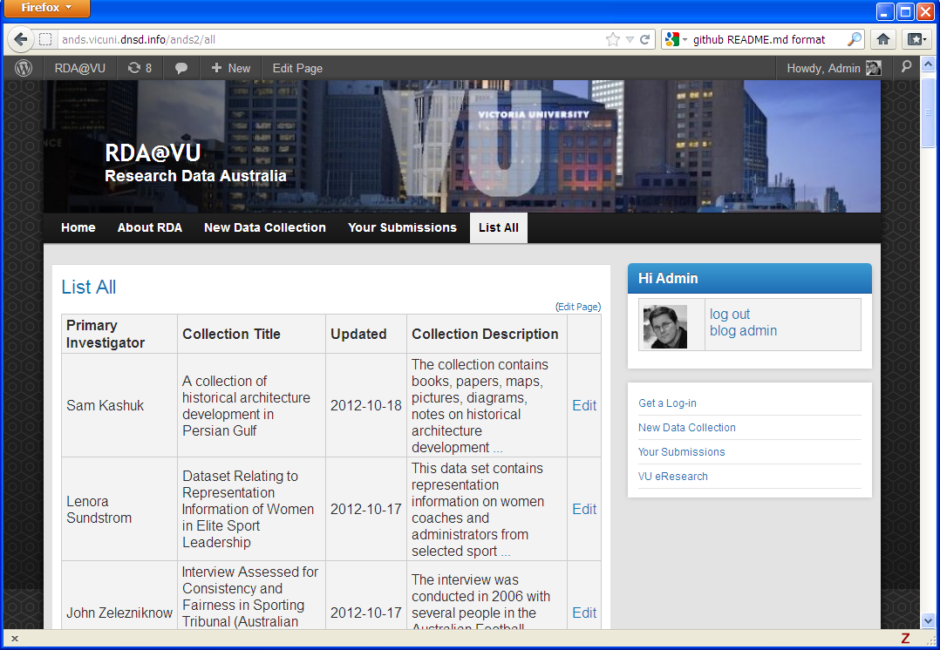
   3. Review all fields for reasonably complete/sensible answers.
   4. Email METADATA REVIEWER to request a review and publish (cut and paste the URL into the email or forward the notification for convenience). Also notify METADATA REVIEWER if collection citation was requested.
4. METADATA REVIEWER **review** filled in form, contact researcher with clarifications/corrections.
   1. Either use the emailed URL or login to WordPress as admin (admin/?password?), from the homepage go to “List All” and click “EDIT” on the saved form entry. The most recent should be listed first.
   2. Review all fields for sensible answers. In particular ensure Descriptions have covered what we require, written in the instructions below each field.
   3. Check for external co-investigators or external people or organisations in the field “*List external people/organisations who must be contacted before granting access or copies.*”. If any, the ownership and copyright statement must be checked for multiple institution ownership. If necessary confirm with the submitter.
5. METADATA REVIEWER **finalise** any people and organisation details:
   1. Look for external people and organisations that already exist in RDA. <http://researchdata.ands.org.au/> Set the “External Person ANDS Key” and “External Organisation ANDS Key” if found.
      1. Do a search for the person and organisation in RDA, selecting only the “Parties” tab.
      2. Found a record? Click on it, then click on the link “ (Registry View)” at the bottom right of the page. Near the top of the subsequent page should be “key”.
      3. Set the “External Person ANDS Key” and “External Organisation ANDS Key” in the filled in form if found.
   2. Update external organisation details if not already in ANDS (static files\Externals.xlsx and read the _READ_ME.txt for details).  
      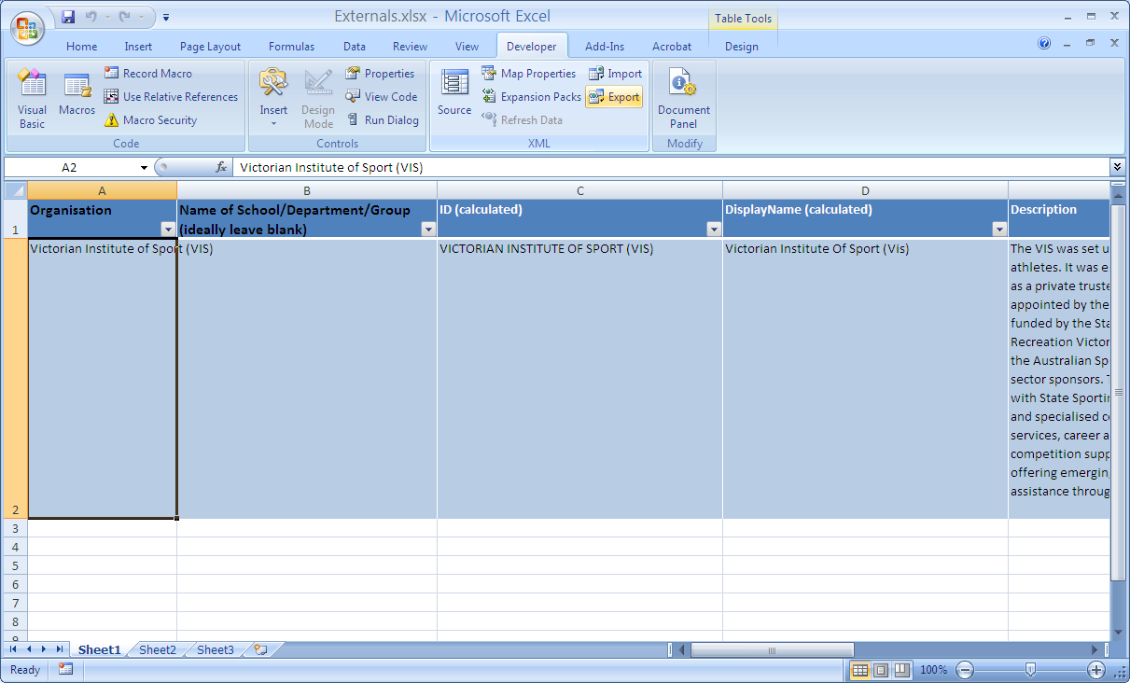
      1. Open "Externals.xlsx" in Excel 2007 or later.
      2. Find the organisation and update the details or add a new entry. To add a new entry select row number 2, right click and “Insert”. (Don’t add rows at the end.) First column “Organisation” must exactly match what is in the form as “External Organisation Name”. “Display Name” is what it will display in ANDS. To remove entries, select the rows, right click and "Delete". Don't just clear the contents. Make sure the row has a unique “Key”.
      3. On the excel Developer tab (along the top ribbon), in the XML group, click "Export" then save to the corresponding XML file, “Externals.xm”. If the Developer tab is not available in the ribon, do the following: Click the round Microsoft Office Button (top left), and then click Excel Options. In the Popular category, under Top options for working with Excel, select the Show Developer tab in the Ribbon check box, and then click OK.
   3. Citation request: If a collection citation/reference was requested you’ll need to create one. eg. creating a handle...
      1. Logon to ANDS Online Services <http://researchdata.ands.org.au/registry/login.php>
      2. “Create Identifier”
      3. *Type:* Description; *Value:* use the Title of Collection/Dataset
      4. Update form “Collection Citation / Reference ID” and “Citation ID Type” to “handle”.
      5. Update “Full Collection Citation / Reference” to:(NOTE: based on [Altman, King proposed standard](http://www.dlib.org/dlib/march07/altman/03altman.html).)

*<Primary Investigator>; <Co-Investigator>; ... , 2012, “<Title of Collection>” hdl:<identifier> Victoria University [Publisher]*

* 1. Change the internal status of the form to “publish”. (Required or the entry is not pushed to ANDS.)  
     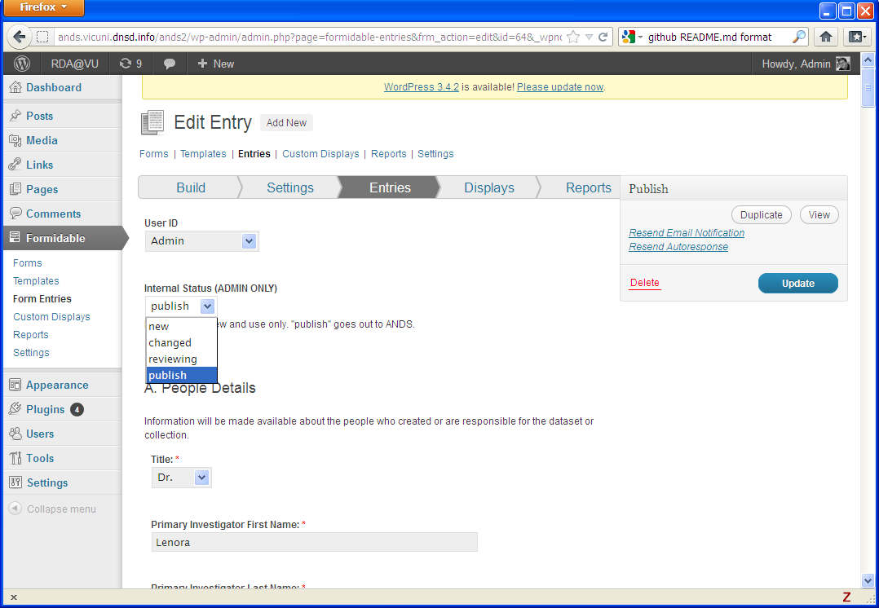

1. METADATA REVIEWER **publish** all records to RDA:
   1. Access the database at <http://hostname/phpmyadmin/> (root/?password?).  
      Click on “thinkred_wrdp4” on left then “SQL” tab. Replace any text in the box with the following text, then click “Go” button on bottom right.   
        
      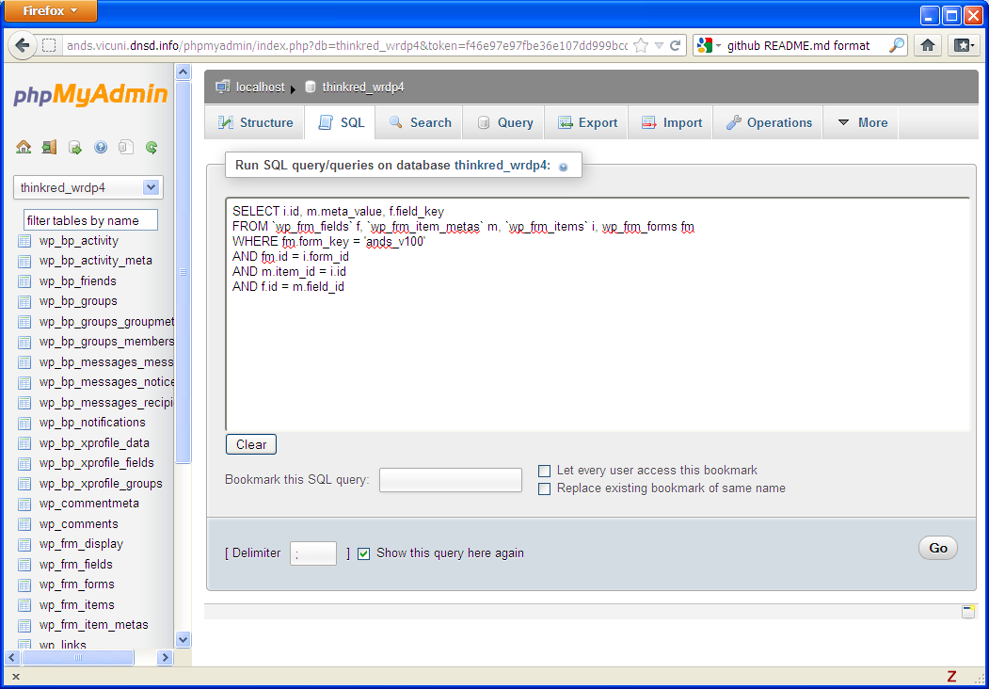  
      Near the bottom click the Query result operation “Export” > with Method “Quick” , Format “XML” > click “Go”, saving file to “wp_frm_fields.xml”. Save to or transfer the file to the folder where the transform is run.  
      (Note: This query on the formidable table creates key-value pairs for each form.)  
      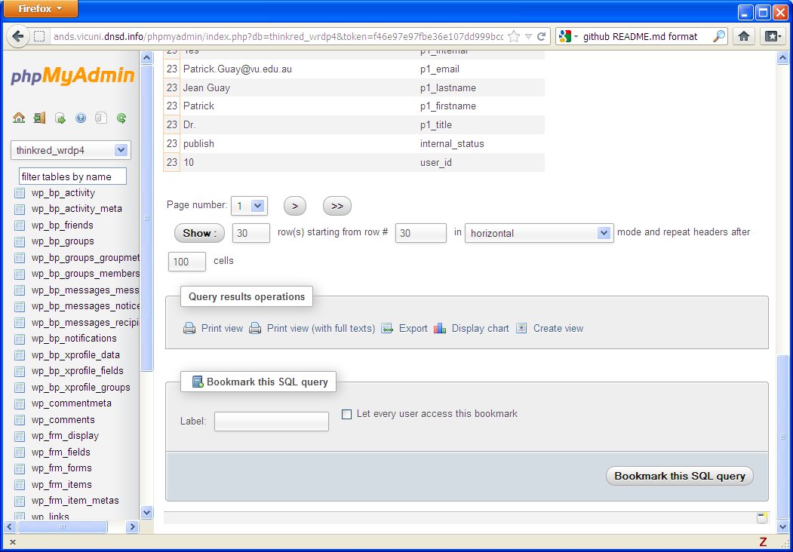

*SELECT i.id, m.meta_value, f.field_key, SHA1(m.meta_value) as hash*

*FROM `wp_frm_fields` f, `wp_frm_item_metas` m, `wp_frm_items` i, wp_frm_forms fm*

*WHERE fm.form_key = 'ands_v100'*

*AND fm.id = i.form_id*

*AND m.item_id = i.id*

*AND f.id = m.field_id*

* 1. Run the script “RUNME.bat” (on windows) or “RUNME.sh” (linux) in that folder, checking for errors.
  2. Upload the output “rifcs.xml” to the URI location expected for harvesting. (See “List My Data Sources” below.) Check that the file is accessible from a web browser, eg.  
     <http://research.vu.edu.au/ands/rifcs.xml>
  3. Request a harvest of the records:
     1. Logon using your AAF credentials to the ANDS Online Services <http://researchdata.ands.org.au/registry/login.php>
     2. Create a backup of our records. Click on My Data Sources “Victoria University”. Then click “Export Records” -> “Download RIF-CS” button. Save export in the “rifcs” folder with date appended to the name eg. “data_source_export20120222.xml”
     3. Click “Import Records” -> “From the Harvester”  
        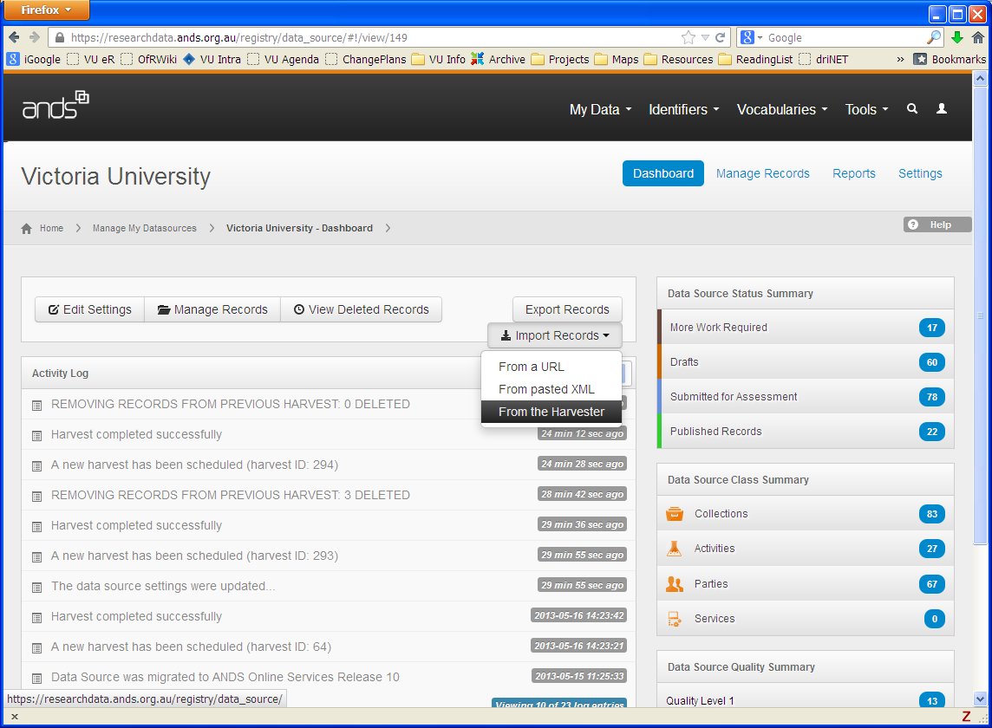
  4. Citation request: If there was a new citation request, update the handle identifier URL metadata:
     1. Find the new collection record’s web address (URL) in RDA
     2. Logon to ANDS Online Services <http://researchdata.ands.org.au/registry/login.php>
     3. “List My Identifiers” then click on the identifier to be updated
     4. Click “Add” button to add type “URL” with the value set to the web address of the collection. “Submit”.

1. METADATA REVIEWER **notify** the new record owners via email that they’ve been registered in RDA! Eg. <http://researchdata.ands.org.au/search#!/group=Victoria%20University/tab=collection>